 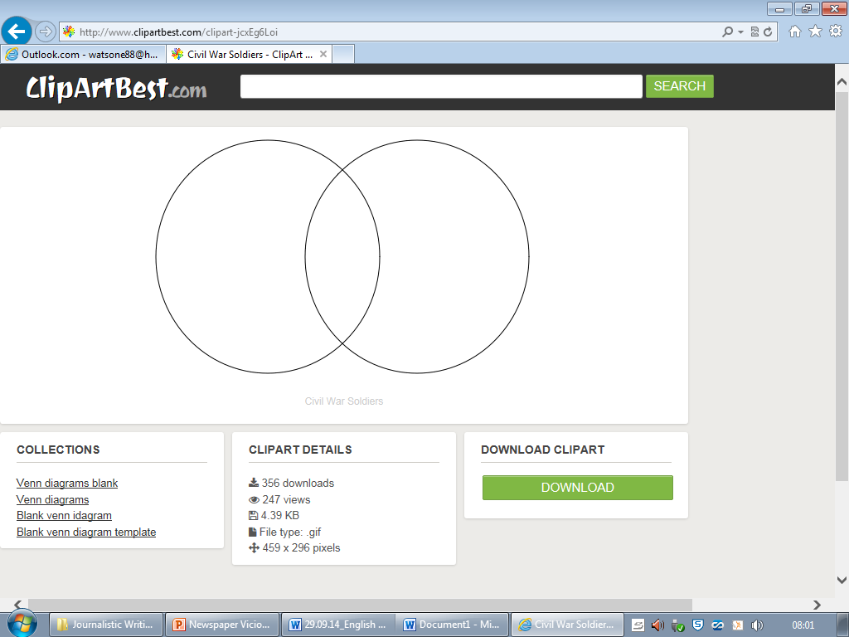

“The Piano”

‘Up clip’

**Venn Diagrams**

Write the similarities and differences you find between the films in the correct places in the Venn diagram.